Web Site with Local Service Pages / Google Maps / SEO Package Deal

Example client Web Site: https://heritageairtx.com

Fully responsive Web site up to (30) pages

- FREE Web site hosting on our servers for (1) year
- FREE USA Phone and email support
- FREE SSL Secure Cert for the best in site security
- FREE Google Analytics setup and monthly stats emailed
- FREE 'Google My Business' profile claiming and optimization
- FREE Up to (2) hours per month of Web site updates

We produce (2) Live actor videos showcasing your services (suitable for broadcast TV, posting on social media and your web site)


Create (20) 'Local Service' pages on your Web site

Ex:

- HVAC Residential Repair in Venus Texas
- Commercial HVAC Services in Dennis Texas

These pages will have content that focuses on a certain service in a certain City.
Content like pictures, Google map, video and city information

Sample page: https://schrader.co/social-media-marketing/traverse-city.html

Optimize and Improve Ranking of your business in Google Maps

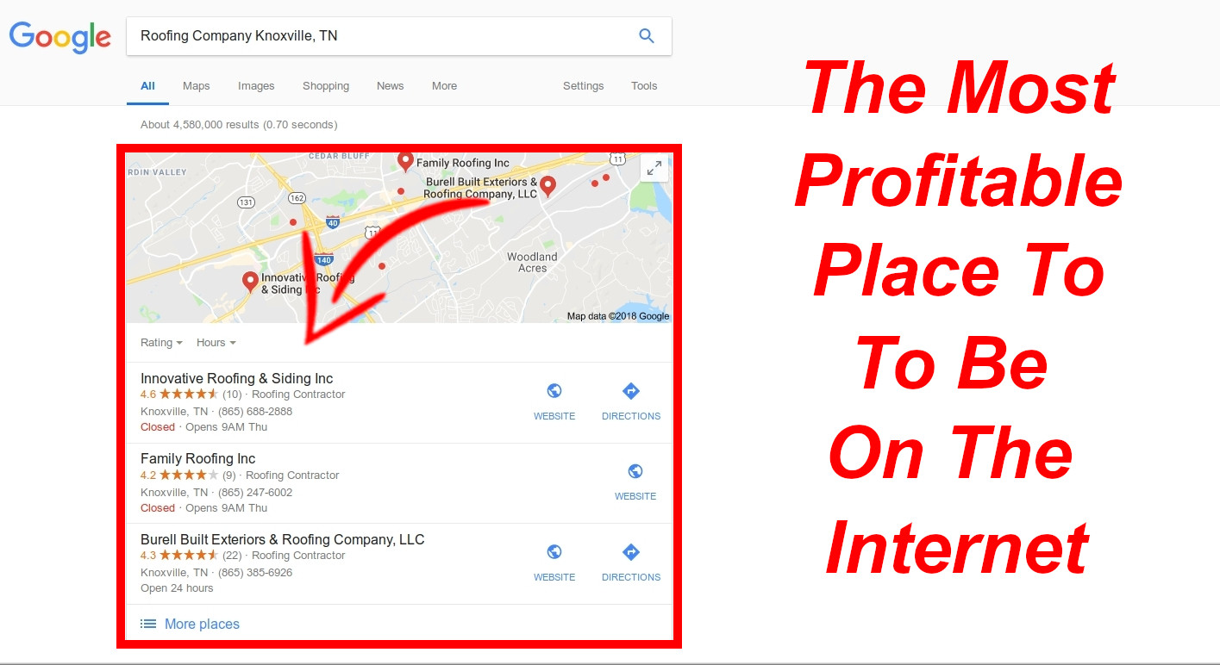

- Best for people searching for your service in your local area
- These results show up at the TOP of Google search.

Includes:

•1 Special Google Map Pack Booster
•300 Local Places (Map Citations)
•45-mile Radius
•10 Geo-tagged photos
•10 Google Stacking Photos(Bonus)
•20 driving point directions
•NAP embedding on the Geo-tagged Map

BONUSES:

+ Youtube Geo-tagged Video
+ (99) High DA Backlinks with Google Map CID
+ Safe 30-Days Drip-fed Paid Links Indexing
+ SEO Recommendations
+ Secret Recipe To Better Rank Your Maps Listing!

Get your business profile listed on 60+ Citation Web sites

High Authority sites similar to Yelp, etc. Very good for building trust and ranking
with Google! This also includes making sure your NAP (Name, Address and Phone) are accurate across all Citation pages.

High Authority Back links To Your Web Site

+ (100)+ Foundation Links to create a solid authoritative base for your site
+ (300) Links From Social Web Sites (Facebook, Pinterest, Reddit, Twitter & more!)
+ My Secret Sauce (A powerful white hat link building tactic)

Click Below To Book Your FREE Discovery Call Today!



